Installing Office 365

The Office 365 upgrade is now available for you to download from the Company Portal. Please follow the instructions below and if you experience any difficulties, please contact the IT Service Desk.

Your laptop will continue to update itself for 24 hours after the 365 upgrade has installed. If the issue isn’t affecting your ability to work, you may wish to wait until 24 hours after your upgrade before contacting the IT Service Desk, in case the issue resolves during that time.

Important:
- Close all applications (excluding the Company Portal) prior to starting the upgrade. Failure to do so will result in a failed download and installation. You can continue to use the online applications accessible via the app launcher on the intranet. The app launcher is on the top left corner of the intranet near the WG Dragon logo.
- This process can take at least 45 minutes and the speed of download and installation will be influenced by your local broadband network and numbers of people using it.
- If you use LWB 360 or CRM applications, please note the additional instructions towards the end of this knowledge article.
- Before proceeding you must have completed both of the following steps:
- Registered in the Company Portal
- Registered your device

Installing Office 365

1) Restart your device and close any applications that have opened automatically. The best way to close applications is through 'Task Manager'.
To open Task Manager, press the CTRL, ALT & Delete buttons at the same time. Select Task Manager and close any applications which may be running, sometimes in the background, such as Microsoft Teams, OneNote and Edge.

2) Open the Company Portal. Click on your start button and access the Company Portal via the A-Z menu.

3) Double click on the 365 Office Apps icon. This will upgrade Word, Excel, Outlook, PowerPoint, Access, and Publisher to Office 365 and update our versions of OneNote and Teams.
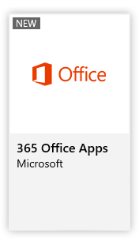

4) Click Install.

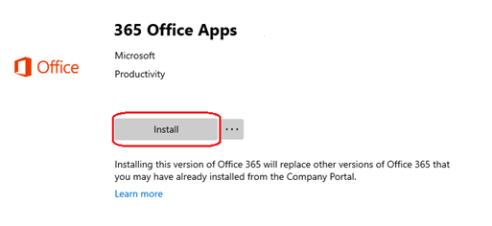

5) The message will show that the download is pending. This can take at least 45 minutes and the speed of installation will be influenced by your broadband network and the number of people using your network in your location.

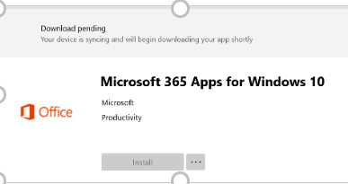

6) A pop-up window will confirm the installation has been successful.

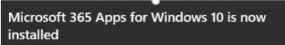

7) If you are licenced to use Microsoft Project, or Visio, you will find the applications within your Company Portal. Please repeat the steps above to install.

8) Please restart once you have installed all required applications.

Installing the iShare Plug-In for use with Outlook
The iShare (Objective) plug-in will automatically install but it could take up to 48 hours. You will be able to use the iShare application as normal during this period. If you wish to install the iShare plug-in earlier:
8) Select the iShare Plugin icon from the Company Portal and repeat steps 4-6 above.

Congratulations, you have completed your Office 365 Upgrade.

CRM Users
- Install Office 365, as above.
- The CRM Outlook plugin will automatically install but it could take up to 24 hours. You will be able to use the CRM application as normal during this period. If you wish to install the plugin earlier, please complete the additional steps set out below.
- Once installed you will need to configure the CRM Outlook Plugin by following the instructions in the Microsoft Outlook - Configuring the CRM Outlook Plugin knowledge article in MyIT.

LWB 360 users
- Install Office 365, as above
- Your existing LWB360 application (32 bit) will remain but it will not work once you have upgraded to Office 365. The upgraded versions of LWB360 application (64 bit) will update automatically over a 24-hour period.
- If you need LWB360 sooner, please complete the steps below.

Accelerating installation of CRM and/or LWB 360 Outlook Plugin

Please Note: The plug-in can take up to 30 minutes to install. You can check whether installation is successful by looking in the Company Portal > downloads and updates.
To install:

1) Click on the start or search buttons in the bottom left of your screen.
2) Type Control Panel and click to open.
3) Open Configuration Manager.

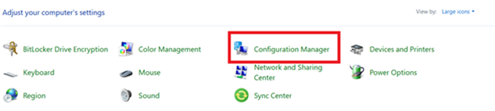

4) Open the Actions tab

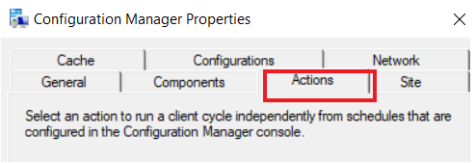

5) Click on “Machine Policy Retrieval & Evaluation Cycle.”

6) Click “Run now” in the bottom corner and press OK to confirm.

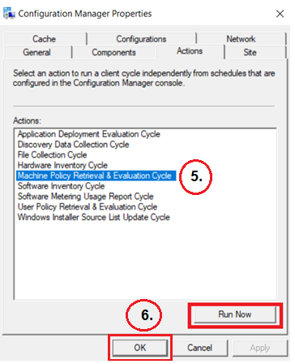

7) Now select “Application Deployment Evaluation Cycle.”

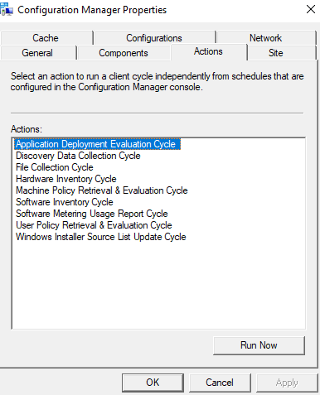
8) Click “Run now” in the bottom corner and press OK to confirm.
9) Finally, click OK.

Congratulations, you have completed your LWB 360 and/or CRM Outlook Plugin installation

