Registering your device
To ensure the forthcoming Office 365 upgrade is successfully installed, it is vital that you register your device. This is in addition to registering for the Company Portal.
The need to register here as well as the Company Portal specifies where your software is installed and some applications, such as Office 365, will fail to install unless this step is completed.
1) Log into Microsoft Intune Web Company Portal (https://portal.manage.microsoft.com) and using the 3 lines, select Devices.
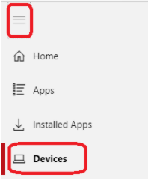
2) Click on the grey banner and a new window will open.
3) Click on the grey banner and a further window will open. Select your device.

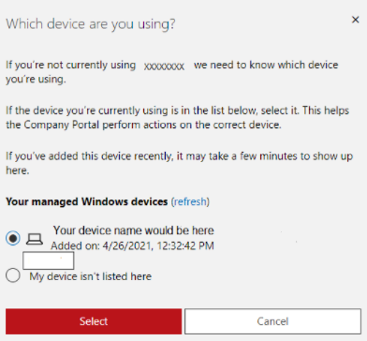
4) Once completed, you will see confirmation that your device has been registered. Please Note: Depending on how many devices you have registered will determine how many boxes you will see.

Congratulations, you have completed your device registration. Don’t forget to register in the Company Portal if you haven’t already done so.

