Registering in the Company Portal

The Company Portal is similar to the App Store on a mobile phone. It enables you to download approved applications at a time to suit you.
The applications that are available are unique to you. Your colleagues may have different options depending on requests they may have made via MyIT. The types of applications that are available via the portal are:
- Optional (you can download them if you would find them helpful. They are available to all)
- Requested (you have submitted a request via MyIT for a specific application)
- Mandatory (they are issued as part of an organisation-wide upgrade).
This knowledge article will show you how to register to use the Company Portal and how to download an application.
Please Note:
- You should also ensure that you register your device in the Intune Portal by following the instructions called Registering your device. This step specifies where applications are installed.
- Subsequent updates to applications you have downloaded from the Portal will be pushed to your device automatically unless IT inform you otherwise.
- Registration only needs to be done once. If you receive a new laptop or phone you will need to re-register.
- If you find you move to Step 6 once you open the App (step 2), you do not need to do anything further to register in the Company Portal. This stage has been completed but you will need to register your device in the Intune Portal as set out above, if you haven’t already done so.
Registering in the Company Portal
1) Open the Company Portal using the A-Z App list in your start menu or search by clicking on your start button or search icon. The Company Portal application appears as a best match.

2) Click on the App to open.
3) Click Sign In and begin the registration process.
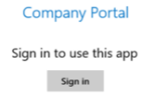

4) Input your email address and log-in password, as if you are logging on to your device. Click Next.
5) Select one of the four options to register your device. Select WG - Windows 10, unless you work overseas or are a contractor or supplier of services. If you are registering on a mobile phone, you would select iOS.
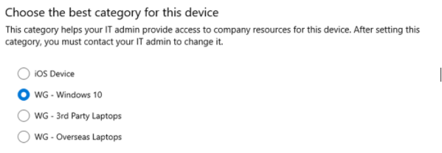

6) The Company Portal will open to show you the available applications that you can download.
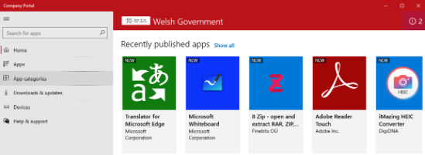

You have completed your Company Portal Registration.
Don’t forget you need to register your device in the Intune Portal if you haven’t already.

